STUDY ON DIABETIC RETINOPATHY BY VESSEL EXTRACTION FROM FUNDUS IMAGES

¹ Prof. Dr.S.S.Chorage , ²Sayali.S.Khot

^{1,2} Electronics & Telecommunication Engineering Department BVCOEW INDIA
Bharati Vidyapeeth College of Engineering for Women Pune,43
Pune University, INDIA
Email: ¹ suvarna.chorage@bharatividyapeeth.edu, ²sayalikhot21@gmail.com
Contact Number::9404413103 ¹,9503677644²

Abstract: Diagnosis and treatment of several disorders that affects the retina and the choroid behind it require capturing a sequence of fundus images using the fundus camera. These images are required for diagnosis of diseases and treatment accordingly. Retinal image segmentation is required to extract various features like hemorrhages that may help in detection of diseases and its treatment. Diabetic retinopathy is one of the leading causes of preventable blindness in the world and a leading chronic diseases in retinal tracking. Detection of lesion helps in early detection of Diabetic Retinopathy

Keywords: Fundus images, Diabetic Retinopathy, Retinal tracking , Lesion, Hemorrhages .

- INTRODUCTION

In diabetic retinopathy, Fundus imaging has an important role for monitoring since occurrences of retinal abnormalities are common and consequences are serious. However, fundus images seems to be sensitive to vascular diseases, that is considered as a non-invasive screening of diabetes. The screening of fundus image depends on the rate of accuracy of fundus image capturing and especially on algorithms accurate and reliable image processing for detecting the abnormalities of fundus images. There are various algorithms that have been proposed by many research groups for such purposes. Because of the lack of commonly accepted and representative fundus image databases and evaluation protocol makes it impossible to judge the accuracy and reliability of the approach of particular diseases. The commonly accepted protocol includes sensitivity and selectivity. This may sometimes allow the technology transfer from research for practice. The main contribution of this work is to evaluate methods for diagnosis of diabetic retinopathy. Experimental results for detection of Diabetic Retinopathy are reported. In order to achieve early diagnosis of diabetic retinopathy a major effort will have to be invested into screening programs. Screening is important as to one third of people with diabetes that may have progressive Diabetic Retinopathy changes without any symptoms of reduced vision of retina.

There are two methods that are supervised and unsupervised methods. In Supervised methods in order to discriminate between vessel and non-vessel pixels, it require a feature vector for each pixel and also manually labeled images. According to the method it uses various classifiers.
Unsupervised methods involves the matched filter responses, grouping of edge pixels, adaptive thresholding , vessel tracking and morphology based techniques. The final segmentation is obtained using an Laplace Operator growing method that derivates the contents of several binary images resulting from vessel width dependent morphological filters. The residual terms in the binary image including some thin vessel segments (or pixels), are classified by Support Vector Machine (SVM). The tracking growth is applied to the thin vessel segments to obtain the whole network by using classifiers to diagnosis the diseases.

Diabetic Retinopathy(DR):

There are two types of DR In type 1 diabetes, there is permanently damaged of insulin production , whereas in the type 2 diabetes, the person is suffering from increased rate of insulin. The type 2 diabetes is related to limited physical activity and lifestyle. The diabetes may cause abnormalities in the retina and various body organs. The diabetes is also a major risk factor various types of diseases . There are no any early symptoms of DR, but slowly it affects the retinal vision. Soon it leads to serious threat of retina and threatens eye sight of person.

- DETAILS EXPERIMENTAL

2.1. Blood vessel detection steps:-

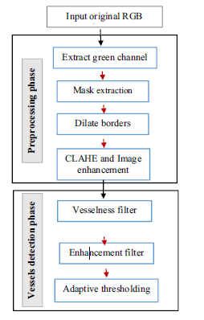
Figure.1.Blood Vessel Detection Steps[7 ]

The steps are divided into two steps. They are given as pre-processing phase and vessel detection phase.

a. Input:
The input given is the original image that consists of Red, Green and Blue region in the fundus images.

b. Extraction of Green Channel:
The Laplace operator is being used to extract the green channel from the fundus image.

c. Dilate Borders:
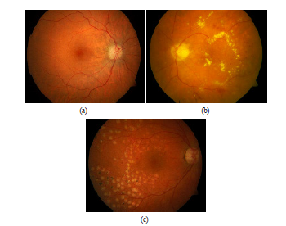
The borders of the fundus images are being dilated to get the borders of the image.

d. Image Enhancement:
The image that is being extracted is enhanced so as to get the vessel of the retina.

e. Vesselness Filter:
The image is being filtered by using different kinds of filter to remove the unwanted parts of image.

f. Enhanment Filter:
Again the enhancement of the image is being done to achieve the required vessels.

g. Adaptive Thresholding :
To acquire the required image the thresholding is being done.

2.2. Automatic methods

The diagnosis of diabetic retinopathy can be divided as following two categories:
1. Screening of the diabetic retinopathy
2. Monitoring of the diabetic retinopathy

The automatic detection system can be done directly by using shape, color, and domain knowledge of DR, but the abnormalities can also be found indirectly by taking fundus images at various angles and comparing those to diagnosis the diseases. The direct approach involves screening of the disease, where indirect approach is both screening and monitoring of the diabetic retinopathy. Both approaches use roughly the above stages for finding abnormalities in fundus images.

2.3. Detection of Diseases

The image that is being achieved is being used for the detection of diseases like DR, glaucoma, Blood Pressure etc. This is done by using the Classifiers like Feature Vector Machine(FVM), Support Vector Machine(SVM) etc. Thus it helps to detect the early stage of DR.

2.4.Fundus Images

Fundus photography is done by capturing a photograph at the back of the eye i.e. fundus. Specialized fundus cameras that consist of an intricate microscope in fundus photography attached to a flashed enabled camera are used. The main structures that can be visualized on a fundus photo are the central and peripheral retina, optic disc andmacula

Figure 2: Fundus images: (a) normal fundus,
(b) abnormal fundus, and (c) abnormal
fundus after treatment by photo-coagulation.[1]

2.5. Graphical representation of Fundus image:

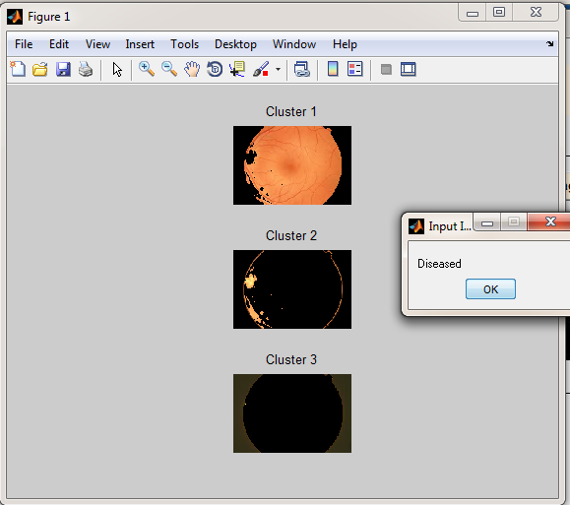
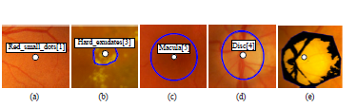
Figure .4. Graphical directives for marking the visual findings: (a) centroid; (b) polygon
region; and (c) circle region; d) semi-automatic region cropping tool and representative
point.[10]
The graphical representation of fundus image shows various regions of retina. This helps to detect the diseases.

- RESULTS AND DISCUSSION

3.1. Pre-processing Results:

In this work, extensive experimentations are performed on publicly available retinal image databases. There are namely three types of databases, DRIVE, STARE and CHASE. These outputs are achieved on mainly DRIVE database
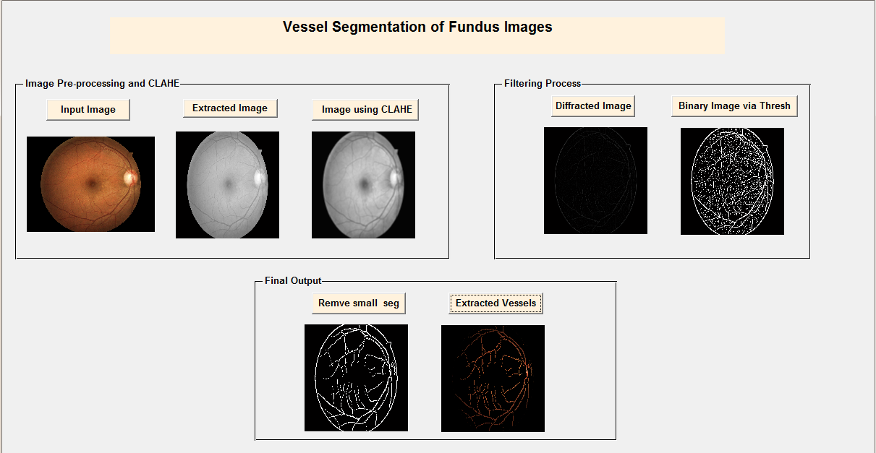

Figure.3. Result of segmented vessels of fundus images

3.2. Diagnosis of Diseases

The detection of various diseases is being done by using various classifiers. Here SVM classifiers is used to detect the diseases. These are the various clusters that are being used to compare are acquire the diseased retinal output. Thus we can achieve the diseases like DR, glaucoma and blood pressure.

Figure.5. Result of diseased retina

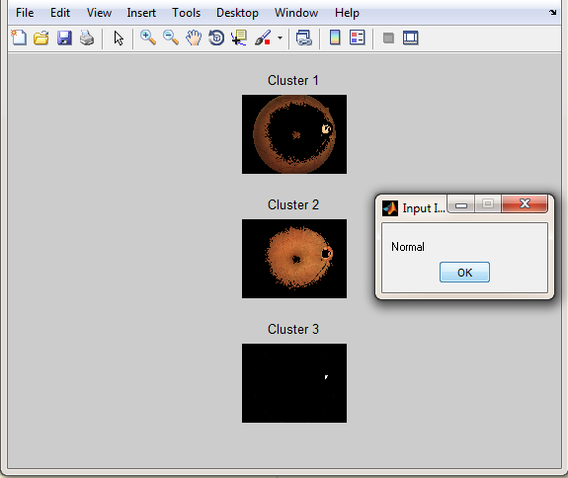

Figure.6. Result of normal retina

CONCLUSIONS

An image database methodology was proposed for evaluating and comparing methods for automatic detection of diabetic retinopathy. It provides a unified framework for benchmarking the methods, it also points out clear deficiencies in the retina. It is observed that analysis of retinal images is the key contribution to detect DR Since its early detection is possible it helps to treat accordingly and thus the vision loss can be avoided.

REFERENCES

- Sohini Roychowdhury,Dara D. Koozekanani and Keshab K. Parhi, “Iterative Vessel Segmentation of Fundus Images”, IEEE Transactions On Biomedical Engineering, Vol. 62, NO. 7, July 2015
- Lama Seoud, Thomas Hurtut, Jihed Chelbi, Farida Cheriet and J.M. Pierre Langlois, “Red Lesion Detection using Dynamic Shape Features for Diabetic Retinopathy Screening”, IEEE Transactions On Medical Imaging, 2015
- Walid M. Abdelmoula, Syed M. Shah, and Ahmed S. Fahmy, “Segmentation of Choroidal Neovascularization in Fundus Fluorescein Angiograms”, IEEE Transactions On Biomedical Engineering, Vol. 60, May 2013
- Shilpa Joshi, Dr P.T. Karule, “Retinal Blood Vessel Segmentation”, International Journal of Engineering and Innovative Technology (IJEIT)Volume 1, March 2012, pp:175-178
- Mai S. Mabrouk1, Nahed H. Solouma2 and Yasser M. Kadah, “Survey of Retinal Image Segmentation and Registration”, GVIP Journal, Volume 6, Issue 2, September, 2006,pp:4-8
- Vijay M. Mane and Prof. (Dr.) D.V.Jadhav Akshay Bansod, “An automatic approach to Hemorrhages detection”, 2015 International Conference on Information Processing (ICIP)Vishwakarma Institute of Technology. Dec 16-19, 2015,pp:27-34
- A.Elbalaoui, M. Fakir and K. Taifi, A. Merbouha, “Automatic Detection of Blood Vessel in Retinal Images”, 2016 13th International Conference Computer Graphics, Imaging and Visualization,pp:324-332
- ManojKumar S B, Manjunath R and Dr. H S Sheshadri, “Feature extraction from the fundus images for the diagnosis of diabetic retinopathy”, International Conference on Emerging Research in Electronics, Computer Science and Technology – 2015,pp:240-243
- https://www.google.co.in/imgres?imgurl=http.plos.org
- https://www.google.co.in/imgres?imgurl=https_Multiscale_Blood_Vessel_Segmentation_in_Retinal_Fundus_Images&docid

